Premiere at ALUMINIUM 2018
Grinding of back-up and work rolls in aluminum rolling mills

Heinrich GEORG Maschinenfabrik:
First roll grinding machine for aluminum rolling mills using CBN technology
New grinding technology cuts machining time by half.
Kreuztal, Germany, September 6, 2018 At the Aluminium 2018 show in Düsseldorf, GEORG is going to introduce its new ultragrind roll grinding machine for aluminum rolling mills. The innovative feature of this machine is the CBN technology. The machine achieves grinding times up to 50 percent shorter than those needed with conventional grinders, while achieving a superior surface quality and longer roll life times.
So far, cubic boron nitride (CBN) cutting tools have only been used for grinding rolls used in steel rolling mills. For Salzgitter Flachstahl AG, GEORG manufactured the world’s first CBN roll grinder in use in a roll shop of a hot rolling mill - where it has proved highly successful.
GEORG is now also introducing this technology to the aluminum industry:
The combination of CBN grinding, measuring during the grinding process and the use of a Siemens 840 D sl grinding control system adapted to the CBN technology achieves grinding times up to 50 percent shorter than other grinders used so far.
In 2019, GEORG is going to deliver the first CBN grinding machine to be used in the aluminum sector: GEORG is manufacturing an ultragrind 50 for the roll shop of the new ELVAL rolling mill near Athens in Greece. The machine will grind back-up and work rolls weighing up to 63 tons, with diameters of up to 1,600 mm and widths of up to 6,500 mm fully automatically.
Dr. Wieland H. Klein, Head of GEORG’s machine tools division, explains where he sees the overall economic benefit for the customer: ”Our new machines come with ultrasonic, eddy current and surface wave systems for integrated crack inspection. This ensures that the rolls are not ground any deeper than absolutely necessary. The advantage for the customer are shorter machining times, longer roll live times and, last but not least, cost savings.”
The machine for ELVAL will be part of the plant-wide process network, as all measurement data acquired during the grinding process will be recorded and transferred to the host computers.
330 words
Heinrich GEORG at ALUMINIUM 2018 in
Düsseldorf, Germany,
9 - 11 October 2018
Hall 9, Stand D40

About Heinrich GEORG Maschinenfabrik
GEORG is a worldwide well-reputed partner for reliable and powerful high-tech engineering solutions. The company’s cutting-edge finishing lines and machine tools as well as production lines, machines and equipment for the transformer industry are in operation in numerous renowned companies around the world.
The various product areas of the family-owned company, which employs more than 480 people and is now in its third generation, cater to most diverse markets and companies throughout the world.
The divisions GEORG Finishing Lines, GEORG Transformer Lines and GEORG Machine Tools are supported by the company’s own manufacturing facilities at the headquarters in Kreuztal, Germany. The company maintains a worldwide network of sales and service branches to be within easy reach for its international customers.
GEORG machine tools
The GEORG machine tools division develops and manufactures advanced value–adding machine tools for turning, drilling, milling and grinding in close cooperation with its customers and optimally tailored to their individual requirements.
Contact:  Heinrich Georg GmbH Maschinenfabrik  Thomas Kleb  Leiter Marketing & Kommunikation  Langenauer Straße 12  D-57223 Kreuztal/Germany  Fon: +49.2732.779-539  www.georg.com  Email: thomas.kleb@georg.com | Press contact:  VIP Kommunikation  Dr.-Ing. Uwe Stein  Dennewartstraße 25-27  D-52068 Aachen/Germany  Fon: +49.241.89468-55  Fax: +49.241.89468-44  www.vip-kommunikation.de  Email: stein@vip-kommunikation.de

Figures:

High-resolution image files are available for downloading at: Photos Georg
Fig. 1: The GEORG ultragrind.50 machine includes a high-precision roll measuring system and fully integrated crack inspection technology.  File name:  Georg-1007_Boden.jpg | 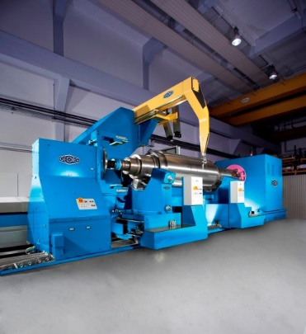
Fig. 2: Taking measurements during grinding shortens the machining time.  File name:  Georg-1080_v.jpg | 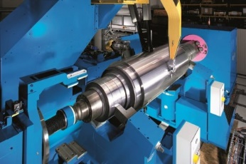
Photos provided by Heinrich Georg Maschinenfabrik

