Press Facts
Grinding of work rolls in the metallurgical industry
Heinrich Georg Maschinenfabrik:
First roll grinder for cold mill rolls
Experts convince themselves at site.
Kreuztal, Germany, March 23, 2015. At the occasion of a customer day Georg presented its new roll grinding machine type ultragrind 700 R to an experienced audience. The new machine is designed for center lengths of 5.000 mm, grinding diameters of up to 700 mm and roll weights up to 10 tons. The machine works fully automatically and impresses by its high grinding qualities in conventional and CBN grinding. Due to many special design solutions, its very solid structure and innovative measuring technologies the machine achieves highest precision and at the same time shortest setting and machining cycles.
More than 70 experts from roll grinding shops of leading steel and aluminium producers as well as experts from roll manufacturers and engineering offices came to see the machine in "live" operation prior to dispatch to the customer Baosteel, China. At first Georg demonstrated the grinding of a work roll in the conventional way and later in CBN technology. In addition GEORG displayed a HSS work roll of a hot rolling mill with CVC profile and a profile height of 1,85 mm that had been ground before with a CBN disc.
During the demonstrations the visitors could inspect the high quality of the machine. Everyone was impressed by the perfect surface quality of the ground rolls, neither comma nor feed marks could be detected. They confirmed that whilst the grinding operations took place no vibrations or swing motions of the machine could be felt and that the machine was running very smooth; this applies to the conventional and to the CBN grinding method as well.
A number of design measures enable Georg to reach excellent grinding results, short handling and machining cycles as well as a long lifetime of the machine. Just to mention the headstock that can be displaced as a whole with fixed main axis and displaceable counter part, the hydrostatic bearing of the grinding spindle and the grinding carriage, the very precise U-axis with a resolution of 0,01 µm, the U1-axis for exact horizontal roll alignment and finally the complete equipment of measuring and control techniques.
Several presentations completed the program of the customer day. Dr. Severin Hannig, MD of planlauf GmbH, Aachen presented new methods for design calcuations and simulations of machine tools, that Georg had applied for the new machine. Hannes Moser (Tyrolit Schleifmittelwerk) and Gerrit Burkhard (Theleico Schleiftechnik) spoke about the optimum usage of grinding discs. Both of them reported about the application of CBN grinding discs, which inspite of higher investment costs may be even more economical when grinding HSS rolls.
2,600 characters including introduction and blanks
Contact:  Heinrich Georg GmbH Maschinenfabrik  Business unit: machine tool division  Langenauer Straße 12  57223 Kreuztal / Germany  Tel.: +49. 2732 779-306  Fax: +49. 2732 779-316  www.georg.com  E-Mail: wzm@georg.com | Press Contact:  V.I.P. Kommunikation  Dr.-Ing. Uwe Stein  Süsterfeldstraße 83  52072 Aachen / Germany  Tel.: +49.241.89468-55  Fax: +49.241.89468-44  www.vip-kommunikation.de  E-Mail: stein@vip-kommunikation.de

Figures
→ Download of high resolution photos: Georg customer day 2015

Fig. 1: Some participants of the customer day in front of the new ultragrind 700 R  File name: Georg GruppeDSC_4059.jpg | 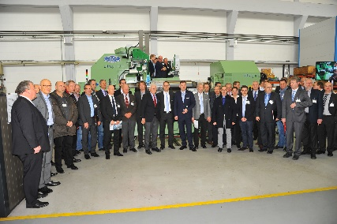
Fig. 2: Dr.-Ing. Wieland H. Klein, Managing Director of machine tool division, explains the features of the new machine  File name: Georg WKDSC_4049.jpg | 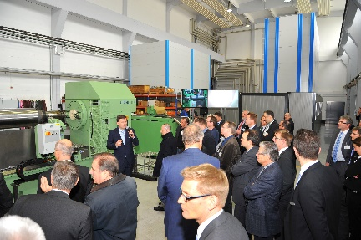
Fig. 3: The new roll grinding machine  ultragrind 700 R  File name: Georg ultragrind 700 R.jpg | 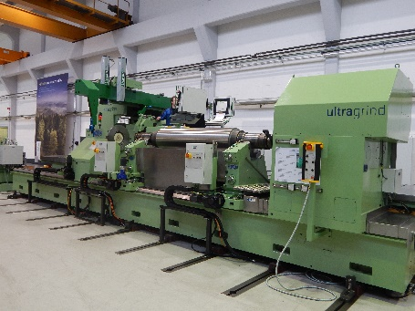
Picture credits: Heinrich Georg GmbH Maschinenfabrik

