Press Facts
Levelling of large-sized plates made of aluminium and steel

Heinrich Georg Maschinenfabrik:
Leveller for plates of „excess width“
Lasers measure the flatness of plates of max. 3.200 mm width in the hundredth of a millimeter range.
Kreuztal/Germany, June 8, 2015 In May GEORG delivered on schedule a levelling center for large-sized aluminium plates to a customer in Russia who is primarily a supplier for the aircraft industry. This machine has been designed for plates of up to 3.200 mm width and max. 12 m length. The heart of the line is the GEORG high-duty plate leveller RM 120 x 3200. Supported by precise measurement technology, GEORG achieves an ultimate flatness of plates during the levelling process, finally documenting a flatness accuracy in the hundredth millimeter range.
After having performed the workshop preliminary acceptance in Kreuztal where GEORG had perfectly fulfilled all specifications instantly, the line is now on the way to the customer. With this new line the customer will be able to produce „laser-competent“ material of extremely low stress which will not distort in the laser welding process of different components.
Initially, GEORG has designed the levelling center for the levelling of large-size aluminium plates but steel plates can be processed as well. In order to meet the very high demands of aircraft manufacturers regarding the flatness of plates between 1 and 10 mm thickness, GEORG has provided the leveller with two levelling roll cassettes including rolls of different diameters. So the customer may use the suitable set of rolls for each plate thickness. With the automatic cassette change car the cassettes can be exchanged in less than 15 minutes.
The machine is equipped with eleven rows of back-up rolls for the precise levelling of plates with edge waves – frequently occurring with annealed aluminium plates – over their entire width. In the infeed area, the levelling rolls have a larger distance in order to facilitate the infeeding of wavy plates. Furthermore the infeed roller table is equipped with centering units to allow different angular positions of plates.
At the leveller exit a laser measuring beam for flatness measurement with eleven stationary triangulation lasers has been installed. The results provide the operator at the control desk a perfect overview during the running process. Thus, he can decide immediately and safely whether the levelling result fulfills the tight flatness requirements or whether another leveling process has to be performed. For the fast transport of plates back to the infeed roller table the machine is equipped with a reversing drive and a fast lifting function of the upper levelling roll set.
For checking and documentation of parameters such as flatness, thickness, length, width and diagonal of the finished plates the line is provided with a stone-type measuring table of highest precision, installed next to the runout roller table. This measuring table enables a one-hundred percent check of plates. For this measurement a measuring beam with triangulation sensors and cameras moves above the plate and detects the geometrical data with an accuracy of a hundredth of a millimeter.
470 words

Contact:  Heinrich Georg GmbH Maschinenfabrik  Finishing Lines Division  Langenauer Straße 12  57223 Kreuztal/Germany  Tel.: +49. 2732 779-249  Fax: +49. 2732 779-375  www.georg.com  E-Mail: band@georg.com | Press contact:  V.I.P. Kommunikation  Dr.-Ing. Uwe Stein  Süsterfeldstraße 83  52072 Aachen/Germany  Tel.: +49.241.89468-55  Fax: +49.241.89468-44  www.vip-kommunikation.de  E-Mail: stein@vip-kommunikation.de

Figures:
Download of high resolution photos: press photos Georg 2015
Picture 1: The new plate levelling machine shortly before delivery to the customer . On the right one can see a cassette change car.  File name:  Georg-34.jpg | 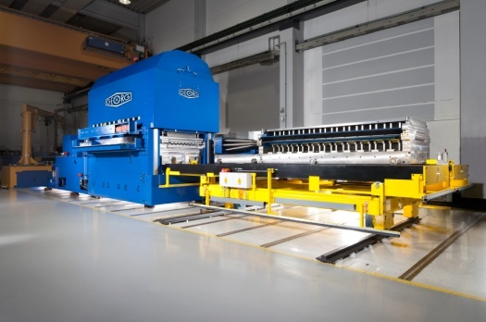
Picture 2: The plates run through the line from right to left, at the rear left the stone-type measuring table is located.  File name:  Georg Tafelrichtzentrum für überbreite Tafeln bis 3200mm-1.jpg | 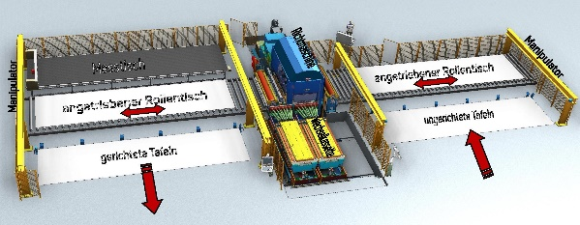
Image credits: Heinrich Georg GmbH Maschinenfabrik

