Press Facts
New Horizontal Machining Center for workpieces of 12 up to 250 tons of weight

Heinrich Georg Maschinenfabrik reduces manufacturing time of large and complex workpieces by weeks
Innovative concept reduces main times, down times, set-up times, waiting and transport times significantly
Kreuztal, Germany, 27. May 2015 On a customer day, GEORG introduced the new Machining Center “ultraturn MC” to manufacturing experts. More than 80 specialists of large part manufacturers came to Kreuztal to witness the premier of the new machine, which is able to handle workpieces from 12 up to 250 tons. The ultraturn MC offers plenty of innovations, which combine highest precision during the machining process with optimum productivity and flexibility. For such large-size parts, the machine reduces the manufacturing time by up to 40 per cent. The integrated 2-point-workpiece measuring system as well as the complete machine enclosure set new standards.
GEORG has developed the new Horizontal Machining Center ultraturn MC for complete machining of workpieces with diameters of 1.100 up to 4.000 mm and almost any length. The center width of the system introduced during the customer day is 10.000 mm. The machine will soon be delivered to its German customer, two more Machining Centers have been ordered by companies in Russia and the Czech Republic.
The ultraturn MC is designed for the machining of complex, heavy workpieces, e.g. for heavy forged parts, rolls, turbines, motor and generator shafts as well as for compressors or pumps for the oil and gas industry. Internal machining of components, such as turning-milling machining or processing of complex inside contours, which are not parallel to the workpiece center line is one of the main characteristics.
New in this range: One machine replaces several others
The ultraturn MC saves a lot of production time since the complete machining, e.g. turning, drilling, milling or grinding and also the measuring is carried out on the same machine. There are no more time-consuming transports between different machines necessary so far as well as associated waiting and set-up times.
By implementing different work steps on one machine, the ultraturn MC not only reduces the production time but also the transport risks of the complex and expensive workpieces. The result: significantly increased and ensured quality of the finished workpieces as well as optimized production planning and scheduling.
Highest productivity with short downtimes and set-up times is the main focus of the new concept. All tool changing processes are carried out automatically, which is a novelty for machines of this size. The tools are stored in the so called tool arena and changed via a six-axis robot which is moving together with the machining unit. This results in minimum access and processing times. Also, the attachment heads in the pick-up magazine are changed automatically and within shortest time.
The machine achieves highest precision due to the 2.000 mm wide machine beds, the hydrostatic guideways of all linear axes and backlash-free NC-controlled drives.
GEORG offers the ultraturn MC in several versions with center widths up to 25.000 mm. The machine presented during the customer day has a center width of 10.000 mm. On the carriage side in S1-operation, the center achieves a milling performance of up to 94 kW and a torque of max. 7.000 Nm directly at the spindle. The carriage is equipped with a hydrostatic guided RAM with a cross section of 700 x 550 mm and a travel distance of 1.600 mm.
New: Machining and measuring without reclamping
With the ultraturn MC GEORG includes the quality control in the production process which is new in the area of large parts machining. The ultraturn MC is the first machining center worldwide, which is not only using a single probe. The moving 2-point workpiece measuring system installed at the milling tower acts like a big micrometer gauge with two probes and measures the workpieces directly at the machine with highest precision. While the measuring of large diameters up to 2.000 mm in measuring machines takes several hours, the integrated GEORG system requires only a few minutes.
New: Complete housing
Also the complete machine enclosure with integrated oil mist removal system is new for exceptionally big machining centers: Nearly no oil mist will exhaust into the shop. Furthermore, the ultraturn MC requires very little space because the enclosure covers the workpiece and the machine itself very tight. The complete machine is mounted deep in the ground so that all components are accessible without steps.
4,500 characters including introduction and blanks

Contact:  Heinrich Georg GmbH Maschinenfabrik  Business unit: machine tool division  Dr.-Ing. Wieland H. Klein  Langenauer Straße 12  57223 Kreuztal / Germany  Tel.: +49. 2732 779-306  Fax: +49. 2732 779-316  www.georg.com  E-Mail: wzm@georg.com | Press Contact:  V.I.P. Kommunikation  Dr.-Ing. Uwe Stein  Süsterfeldstraße 83  52072 Aachen / Germany  Tel.: +49.241.89468-55  Fax: +49.241.89468-44  www.vip-kommunikation.de  E-Mail: stein@vip-kommunikation.de

Figures
→ Download of high resolution photos: press photos Georg 2015
Image 1: International participants of the customer day during the machine presentation.  File name:  GEORG DSC_5676.jpg | 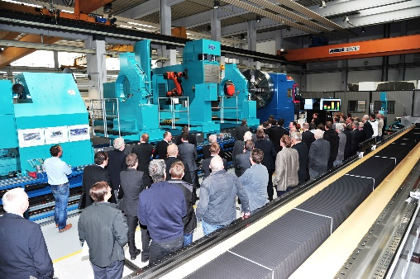
Image 2: Dr.-Ing. Wieland H. Klein, Managing Director of the Machine Tool Division at GEORG, explaining the new machine.  File name:  GEORG DSC_5670.jpg | 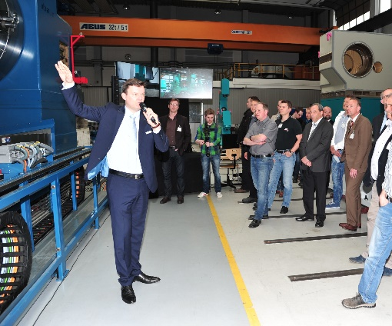
Image 3: The ultraturn MC is installed deep in the ground, so that all components are accessible without steps.  File name:  GEORG Ultraturn Gesamt -1.jpg | 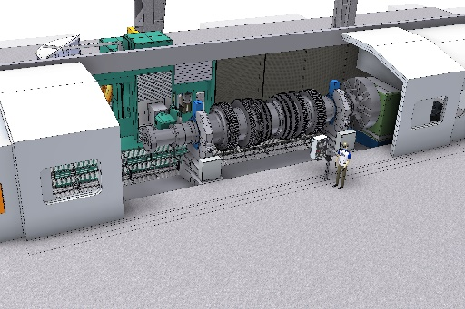
Image 4: The new ultraturn MC before delivery to the customer, still without housing.  File name:  GEORG DSC_5645.jpg | 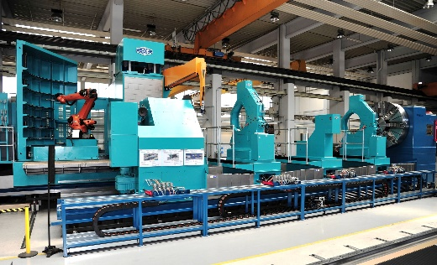
Image 5: The tool arena comprises up to 106 tools.  File name:  GEORG Ultraturn MC Walzenbearbeitung.jpg | 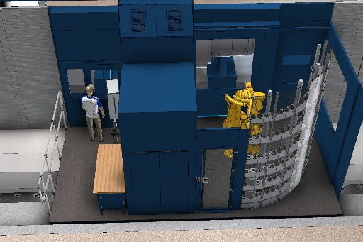
Image 6: The ultraturn MC drills flange holes up to 150 mm of extremely high precision.  File name:  GEORG ultraturn MC Bohren.jpg | 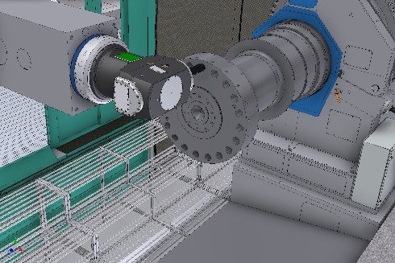
Image 7: The ultraturn MC is suitable for the machining of rolls including grinding (picture) and the machining of roll necks.  File name:  GEORG ultraturn MC Schleifbearbeitung Walze.jpg | 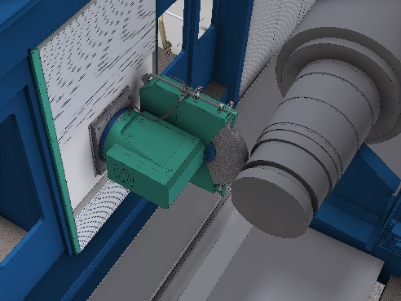
Picture credits: Heinrich Georg GmbH Maschinenfabrik

