Press Facts
Plant technology for steel service centers
Heinrich GEORG Maschinenfabrik: New slitting line for Eisen + Stahl Service Center
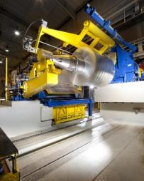
High efficiency through short non-productive times
Kreuztal, Germany, August 10, 2017 GEORG has received an order to manufacture and supply a new slitting line to the German steel service center E + S Eisen + Stahl Service GmbH. With the new line, the Mannheim-based company will be adding the sale of slit strip out of its own facilities to its portfolio, thus taking another important step towards metal product processing in addition to trading.
Eisen + Stahl sells steel, stainless steel and aluminum sheet and plate, which the company cuts in its own facilities to the sizes demanded by its customers. To date, slit strip ordered by customers has been sourced from third parties. With the new slitting line supplied by GEORG, Eisen + Stahl will in the future be able to slit the strip at its own facilities in Mannheim. Thus the company will be able to cater to call-off orders much more flexibly. Additionally, the new line will reduce the company’s dependency on third-party supplies.
The new line will be designed to handle up to 1,650 mm wide and up to 5 mm thick steel strip, or up to 2 mm thick strip in stainless grades. It will be able to produce up to 30 slit coils from one mother coil at speeds of up to 400 m/min. The new line will be designed to optionally pay the strip off from above or below. Thus slitting can be performed with the inside or outside coil surface up, whatever may be requested by the customer.
Thanks to the high degree of automation, the GEORG slitting line will have much shorter non-productive times than traditional lines. For example, removal of the slit coils from the recoiler and placement of the coils on the payoff reel will take place synchronically. Any knife changes that may be necessary will also be performed in the process.
The scrap chopper features GEORG’s “shimless tooling” technology, which dispenses with the necessity to insert shims while the knives are being reground.
The automatic, patented CNC-based system for arranging the separators saves setup times. While in the past, the separator discs used to be installed manually, this system now automatically sets the separator discs precisely at the correct positions, without any manual intervention. With four separator shafts in place, the new machine achieves optimally wound coils.
Against the backdrop of high energy costs, GEORG will equip the machine with highly energy-efficient motors and drives. Certain plant components, such as the brake rollers, will be operated in generator mode, allowing them to feed excessive energy into a link.
Axel Sturm, Head of Sales of GEORG’s Finishing Lines division, emphasizes that the lines made by GEORG are of interest not only for the big strip producers: “The order for E + S demonstrates that investing in quality-equipment from GEORG also pays for small and medium-size businesses. Last but not least the high degree of automation and proven longevity make our machines extremely attractive for steel producers and steel service centers as well.”
Dominik Naber, Managing Director of E + S, explains why he decided to buy a GEORG slitting line: “GEORG equipment is known for excellent precision, short non-productive times and long lifetimes. Of course, also costs mattered. But considering its overall duration of service, the new machine also provided major advantages in terms of total cost of ownership.”
The new line is expected to start producing at the E + S facilities in Mannheim in September 2018.
3,400 characters including blanks and introduction
About EISEN + STAHL Service Center GmbH
Eisen + Stahl Service GmbH, based in Mannheim, Germany, is an owner-managed steel trading company looking back on more than 40 years of business. The family-owned company sells sheets, plates and slit strip made of hot or cold-rolled, hot-dip galvanized or zinc-plated steels, stainless steel grades or aluminum, in standard or customized sizes.
The current facilities include as key assets a cut-to-length line for 6,000-mm-long sheets, a recoiling plant and a fully automatic plate shear. Its extensive stock of items stored over an area of more 10,000 square meters allows E + S to instantly deliver products to customers all over Europe.
The company is certified to DIN EN ISO 9001:2008.
About Heinrich GEORG Maschinenfabrik
GEORG is a business partner worldwide well-reputed for reliable and powerful high-tech mechanical engineering solutions. The company’s cutting-edge finishing lines and machine tools as well as production lines, machines and equipment for the transformer industry are in operation in numerous renowned companies around the world.
The various product areas of the family-owned company, which employs more than 450 people and is now in its third generation, cater to most diverse markets and customers throughout the world. The company structure is based on a divisional setup, with three divisions acting on the market as independent profit centers.
The divisions GEORG Finishing Lines, GEORG Transformer Lines and GEORG Machine Tools are supported by the company’s own manufacturing facilities at the headquarters in Kreuztal, Germany. The GEORG Corporate Services division completes the portfolio with a wide range of value adding services. The company maintains a worldwide network of sales and service branches to be within easy reach for its international customers.
GEORG Finishing Lines
The Finishing Lines division manufactures a wide range of slitting and cut-to-length lines as well as multi-blanking, side trimming, inspection, recoiling and packaging lines and high-precision heavy-duty roller levelers. The lines provide long-term efficiency, as they are characterized by very short setup times, ease of operation, low HR requirements and perfect, process-controlled operation.
For more information please visit
www.georg.com
Contact:  Heinrich GEORG GmbH Maschinenfabrik  Thomas Kleb  Leiter Marketing & Kommunikation  Langenauer Straße 12  57223 Kreuztal/Germany  Fon: +49.2732.779-539  Fax: +49.2732.779-39171  www.georg.com  E-mail: thomas.kleb@georg.com | Press contact:  VIP Kommunikation  Dr.-Ing. Uwe Stein  Dennewartstraße 25-27  52068 Aachen/Germany  Fon: +49.241.89468-55  Fax: +49.241.89468-44  www.vip-kommunikation.de  stein@vip-kommunikation.de
Figures and captions
High-resolution image files are available for downloading at:
Pressefotos Georg
Fig. 1: GEORG slitting lines excel in terms of winding accuracy; the photo shows a plant, delivered in the past.  File name:  Georg-1092.jpg | 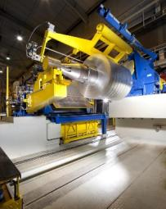
Fig. 2: High-precision bearings of the knife shafts guarantee that GEORG slitting lines provide exact cuts with minimum burr even if a great number of closely arranged cuts are required.  File name:  Georg 48 Streifen.jpg | 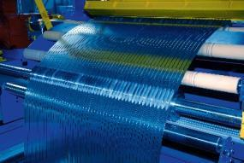
Fig. 3: The staff of Eisen + Stahl Service GmbH in Mannheim.  File name:  E+S IMG_7296.jpg | 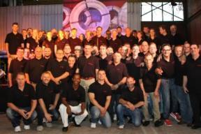
Copyright photos:
Figures 1 and 2: Heinrich GEORG Maschinenfabrik
Figure 3: Eisen + Stahl Service GmbH

