Press Facts
Manufacture of distribution and large power transformers
Strategic cooperation between Georg and Güdel Group
Transformer core production on the way to industry 4.0 / IoT
Kreuztal/Langenthal, Germany, June 19, 2017 Heinrich Georg Maschinenfabrik and Güdel Group AG concluded a cooperation agreement for the collaborative development of lines for the automatic stacking of transformer cores. GEORG brings in their know-how in the plant engineering field, Güdel the robot technique for the automatic stacking of the laminations. That way, systems are constructed in the future that speed up the production of transformers, reduce manual time and enable a higher production flexibility. Furthermore, the intensive data transfer prepares the ground for industry 4.0 / IoT.
GEORG is leading in the manufacture of production lines for the transformer industry and already has own automation solutions. However, for the manufacture of power and big distribution transformers of up to several hundred tons, many GEORG customer often still stack the individual laminations for the transformer cores manually which is very time consuming. The potential of modern handling systems and the networking of data often remains unused so far. Especially for offline systems, there are only few highly automated systems.
On the basis of their gantry robot, Güdel has already developed an automatic core stacking system for transformers in the 50 kg to 350 tons weight range which was put into operation at a leading European transformer manufacturer. The in-house manufactured gantry robots do not require any external centering units thanks to their high positioning accuracy and repeatability and thus reach significantly lower production times.
With their leading technologies, Güdel Group realises solutions for motion tasks in the individual automation. Martin Sträb, CEO of Güdel Group, emphasises “we will be able to work out even better automation solutions for the transformer industry together with our partner GEORG. The efficiency will be increased further and thereby also the satisfaction of our customers. I look forward to our collaborative work”.
GEORG brings in profound knowledge of the entire line technique in the transformer industry – from the decoiling of the strip from the coil over the cutting-to-length of the strip to the cutting of the laminations and the stacking of the cores. Güdel contributes the robot handling systems and the networking of the individual components among each other.
As there are several GEORG customers who cut ahead and stock laminations which they want to stack to a core with an offline system at a later stage, the focus for the first common projects will be the development of an offline system for the automatic stacking of transformer cores.
The laminations cut by the GEORG line and interim stored are picked up and stacked fully automatically by the Güdel robots. For the positioning, the robots achieve highest accuracies and beyond that accelerate the core stacking process significantly. The direct data transfer from the cutting line to the robot unit makes time-consuming manual processes redundant. By this data coupling, the new systems can be easily integrated into digitally networked environments and thus prepare the ground for industry 4.0 / IoT.
Bernd Peter Schmidt, Managing Director of the transformer business division at GEORG sees considerable benefits for his customers: “By the cooperation of our two companies – who both have an outstanding reputation in their respective field – we will deliver complete systems that make the stacking of the laminations much more effective. We make use of the vast experience and well-proven standard components of Güdel. This means for our customers: innovative and at the same time reliable technology with considerable cost advantages.”
Rocco Montalenti, General Manager Business Unit Technologies at Güdel relies on the market knowledge of GEORG: “For more than 30 years, GEORG manufactures transformer lines and has an impressive market share worldwide. The GEORG employees know the conditions in the transformer industry inside out. By this, we are able to elaborate single-source solutions together that are exactly adapted to the requirements of our common customers.”
The cooperation is in accordance with the philosophy of both companies to offer optimal solutions for smooth transformer production processes.

4,200 characters including blanks
About Georg
For high-tech solutions in plant engineering Georg is worldwide a renown partner. The advanced finishing lines and special purpose machine tools as well as production lines and units for the transformer industry are internationally in operation at well known companies. With its different product areas the family company, in its third generation with 450 employees, serves various markets and customers worldwide. Georg is organized in divisions with three individually operative business units working on the market as profitcenters.
The business divisions Georg finishing lines, Georg transformer lines and Georg machine tools are supported by an own manufacturing division at the company headquarter in Kreuztal / Germany (NRW). In addition a number of central functions are grouped in the division Georg corporate services. Internationally the company is close to its customers with a worldwide sales- and service network.

Georg transformer lines
As technology and world market leader Georg engineers with creative step ahead in technology efficient and advanced machinery, lines and units for transformer production. More than 900 lines supplied worldwide to well known transformer manufacturers underline the trust in leading Georg technology.

For further information, please visit: www.georg.com

Güdel Group AG
Güdel Group is manufacturer of high-precision machine components and supplier of intelligent automation solutions. The product range comprises linear guideways, racks, pinions and gears as well as linear and rotary axes and gantry robots. Güdel puts the products together to achieve systems with special control intelligence and complete lines which are used in the sectors automotive, tyres, metal, rail, intra logistics, pharmacy, renewable energies, wood and aerospace.
The Güdel technology stands out by innovation, quality and modularity. Güdel Group employs around 1.200 people at more than 30 locations worldwide. Since the foundation over 60 years ago, the group is family owned.
Güdel Group headquarters is in Switzerland.
Contact:  Heinrich Georg GmbH Maschinenfabrik  Thomas Kleb  Marketing & Communikations  Langenauer Straße 12  57223 Kreuztal, Germany  Tel.: +49.2732.779-539  Fax: +49.2732.779-39171  www.georg.com  E-Mail: thomas.kleb@georg.com | Press contact:  VIP Kommunikation  Dr.-Ing. Uwe Stein  Dennewartstraße 25-27  52068 Aachen, Germany  Tel.: +49.241.89468-55  Fax: +49.241.89468-44  www.vip-kommunikation.de  stein@vip-kommunikation.de
Figures and captions
Download of photos in print quality: press photos Georg
Fig. 1: From left to right: Martin Sträb, CEO and Member of the Supervisory Board Güdel Group, Bernd Peter Schmidt, Managing Director transformer division and Member of the Board Heinrich Georg GmbH  File name:  Georg GEORG+GÜDEL.jpg | 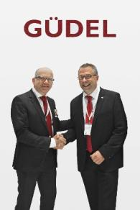
Fig. 2a: The aim of the first joint projects is the development of an offline e-stacking solution for automatic stacking of transformer cores.  File name:  Georg Robotarm2_05172017.jpg | 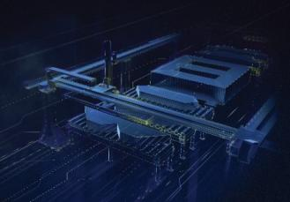
Fig. 2b: The aim of the first joint projects is the development of an offline e-stacking solution for automatic stacking of transformer cores.  File name:  Georg Robotarm2_05172017a.jpg | 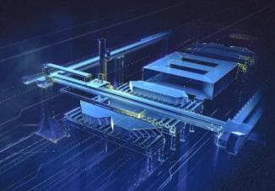
Photo credits: Heinrich Georg

